1. What is the difference b/w Entry Point & CMD…?

**Entry point** :-  you cannot overwrite the entry point.

**CMD** :- you can overwrite the CMD if any changes in CMD you make changes in CMD you have build it again.

1. What is the Workflow of KUBELET & KUBE PROXY…?

**KUBELET** :- 1. what are the requirements wants to the NODE server it communicate with the KUBELET

Server KUBELET communicate with KUBE API Server.

2. KUBELET is always Sink with the KUBE API SERVER

3. if Node wants to DATA BASE PASSWD

KUBELET talks to the KUBE API server After that KUBE API SERVER

Gives the Passwd to the NODE Server

**KUBEPROXY** :- it edit the container ports & it network level flows the TRAFFIC Allow & Deny

3.how to create yaml for pod deployment?

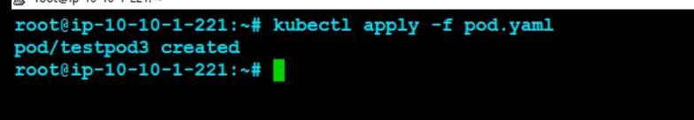

4.how to check the pods in Kubernetes? 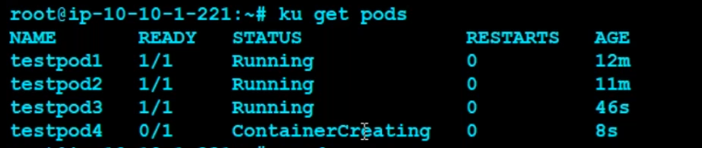

5.how to check pod in specific name space?

6.what type of volumes in Kubernetes?

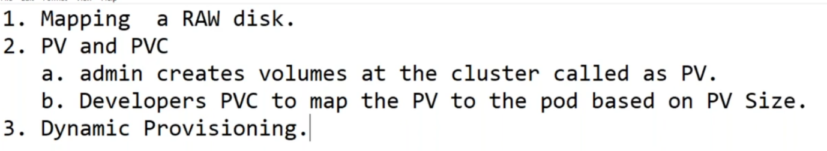

7.How to check get information specific pod?

8.wt is name space in Kubernetes?

What is Namespace in Kubernetes/k8s ? It is**Kubernetes objects** which is used to create multiple virtual clusters within same physical cluster. We can deploy Pods, deployment, service within each Virtual Cluster called as Kubernetes Namespace.

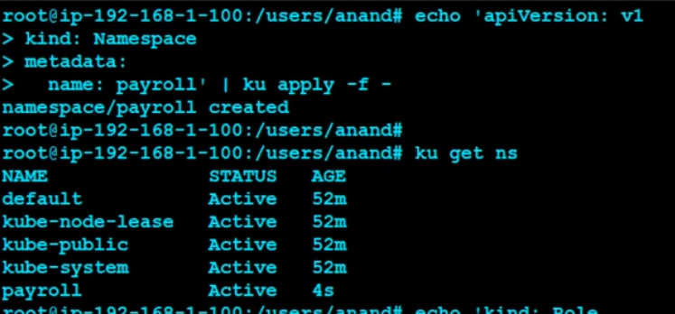

9.Wt is diff between the docker & Kubernetes

One stark difference between Kubernetes and Docker Swarm is that you can use the latter without any container runtime because of its integration with the Docker ecosystem, but Kubernetes needs a container runtime or a component to run a container on the operating system of the host, like Docker Engine for orchestration.

10.wt is resourses in Kubernetes?

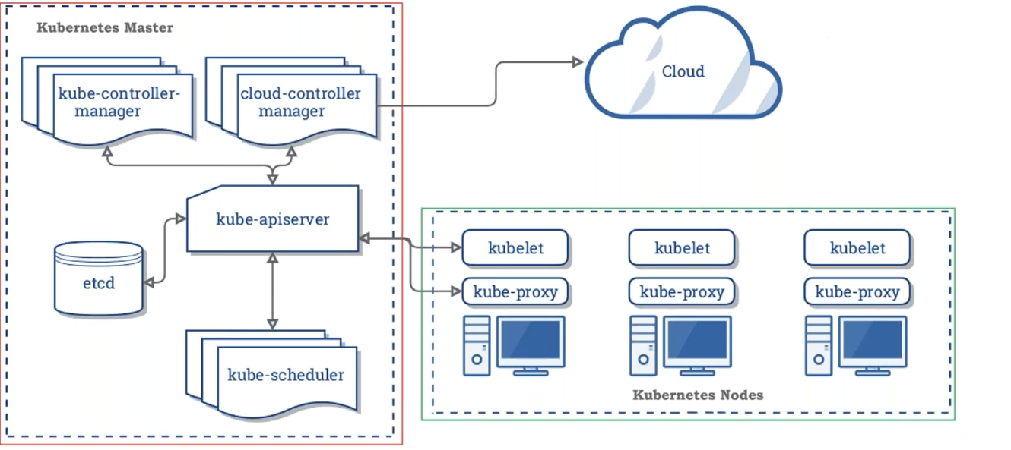

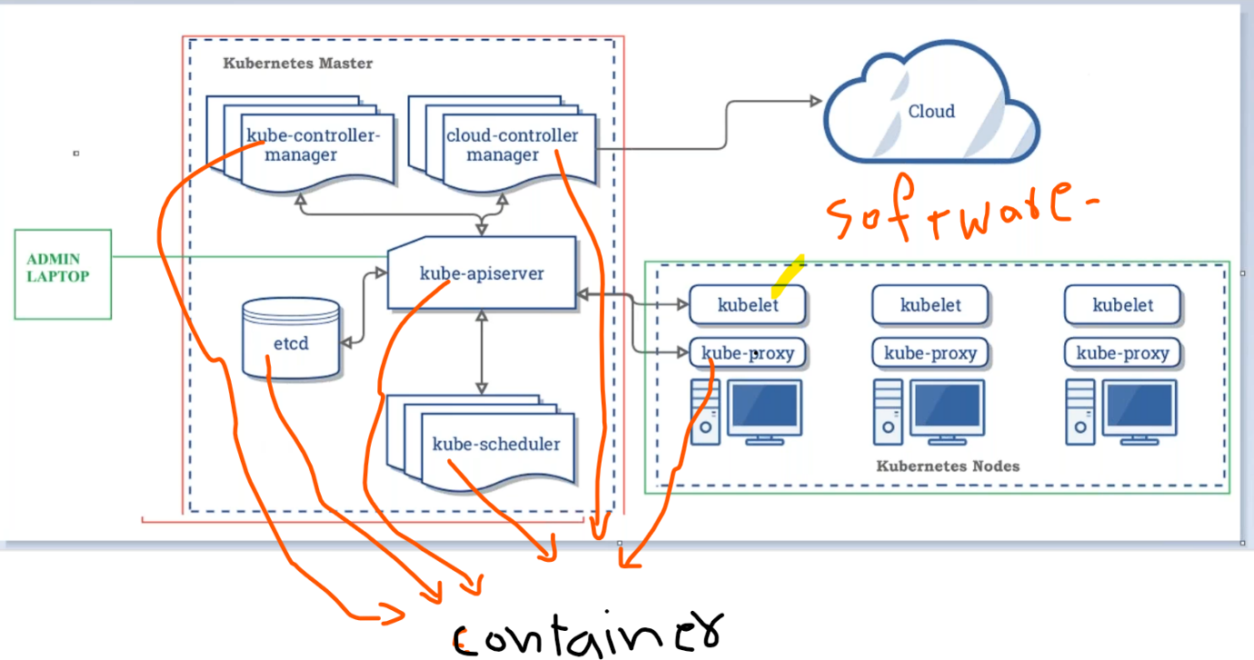

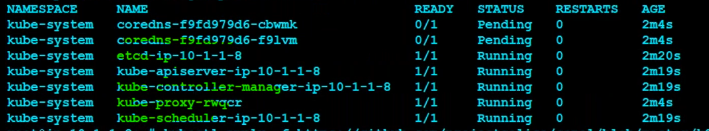

11.wt is api server in kuberenetes?

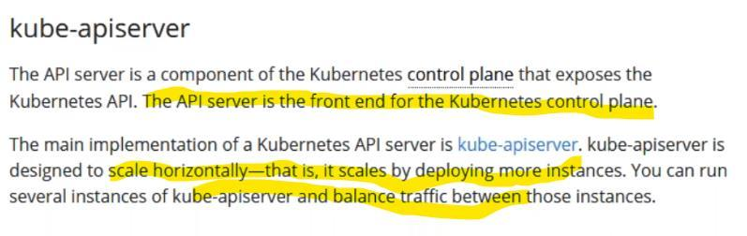

Primary level endpoint for communicationg with k8s cluster

12.wt is etcd in Kubernetes?

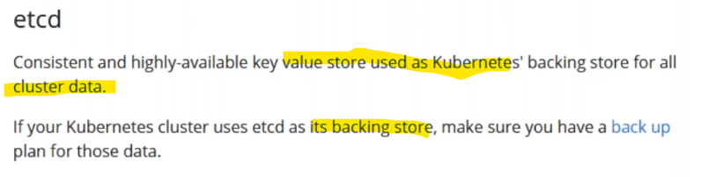

Only kube api server communicating with etcd and etcd commucationg with apiserver.

Etcd act as RAFT ALGARITHAM

13.wt is kube shedular in Kubernetes?

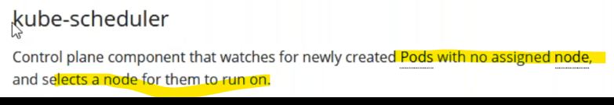

14 wt are the kube controller in k8s?

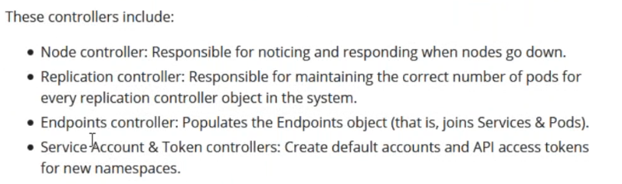

15.wt is cloud control manager?

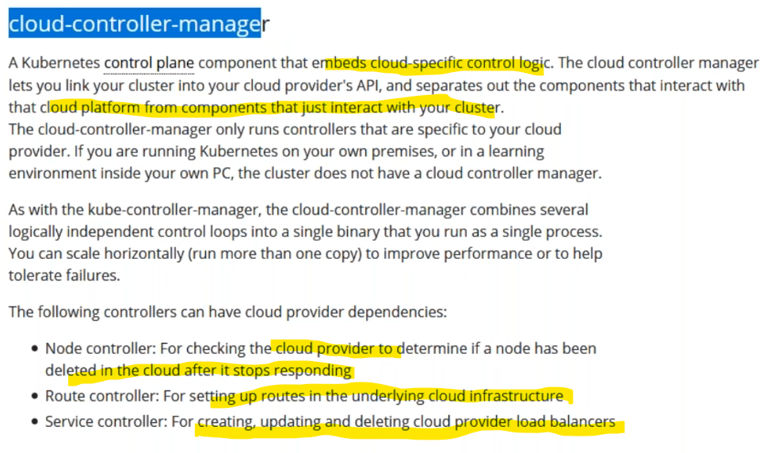

16.Wt is  kubetlet in worker node?

Each node have kubelet

Kubelet running as a software

Kubetlet communicating with api server & get information related pod & kubelet helped to pod running in worker nodes

17.Wt is kubeproxy in worker nodes?

Its acts edit the ip table

& after created pod&it is acts allow or deny out side traffic  to communicate with pods

18.how to check pods in specific name space

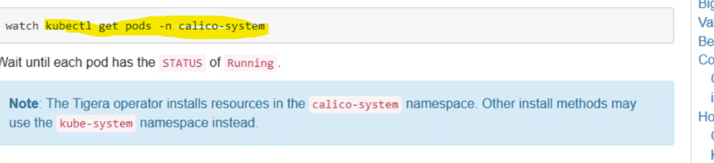

19.How to describe pod informationin in Kubernetes?

Kubectl describe pod venu



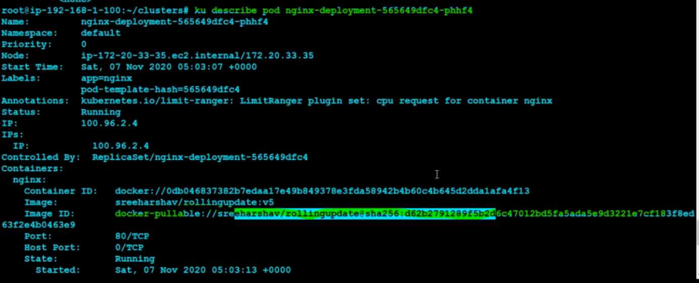

20.Wt are the services in k8s?

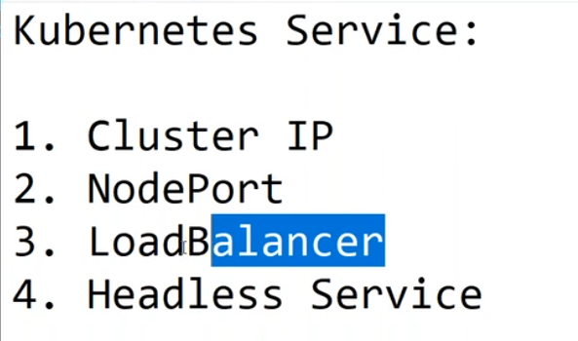

Wt is cluster ip in Kubernetes?

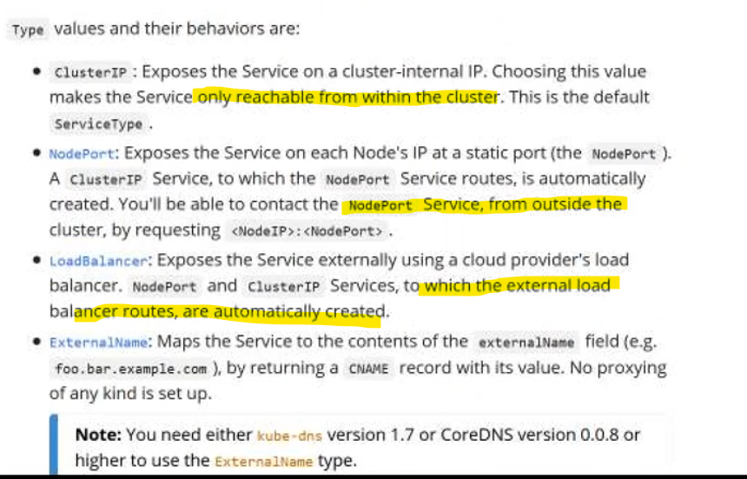

21.How to create cluster ip in k8s?

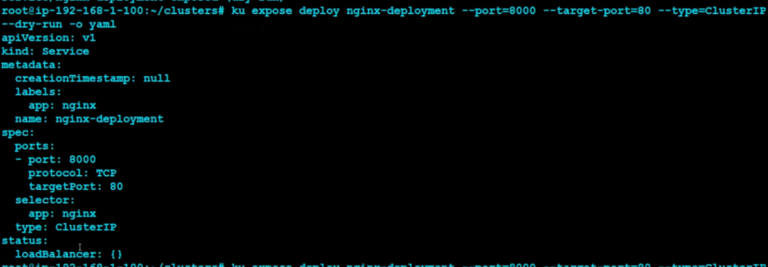

22.kubectl describe rc create

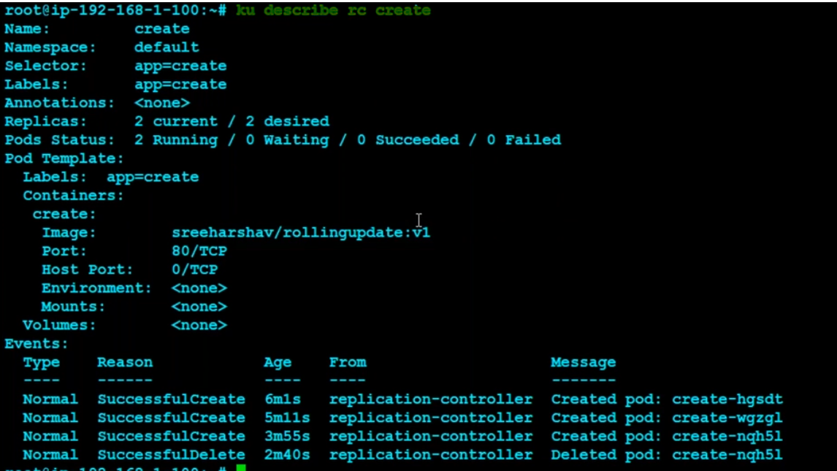

23.

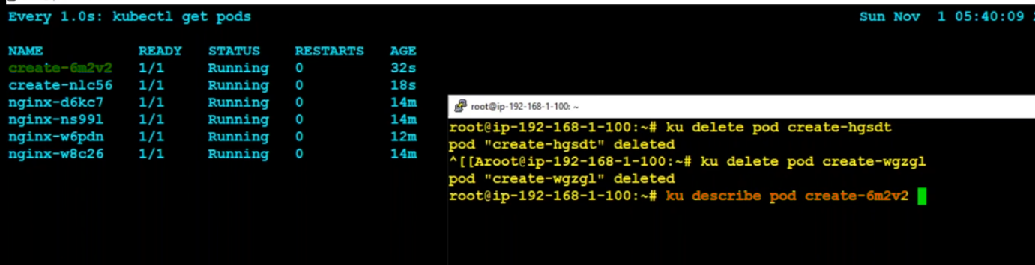

replication set vs deployment set

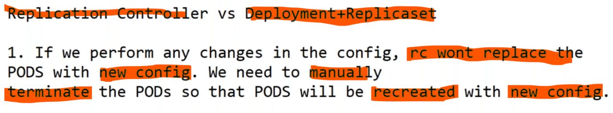



2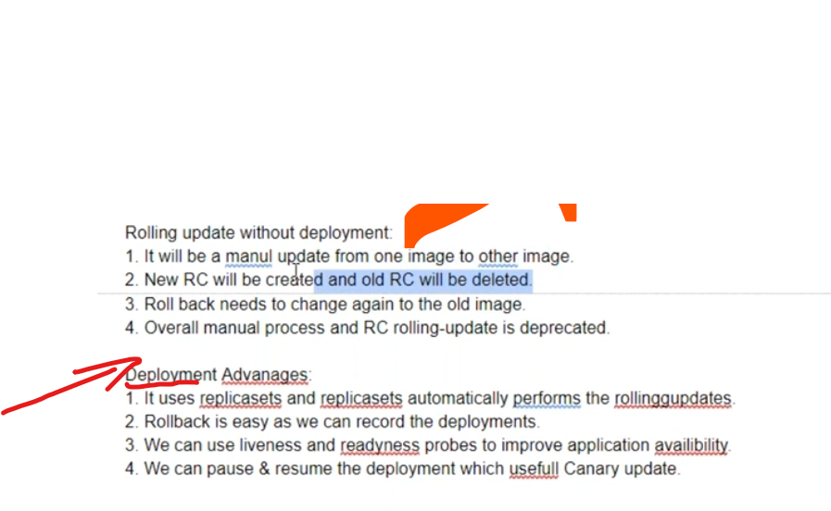

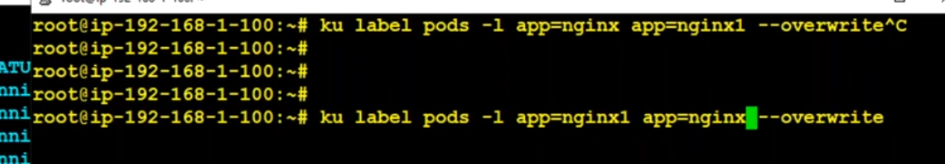

24,can u please write pod deployment

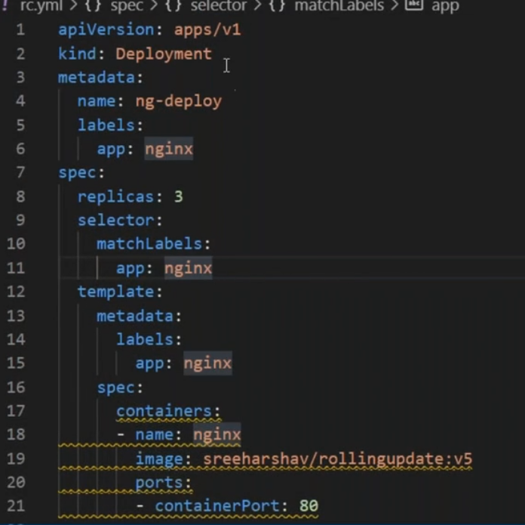

25.kubectl log

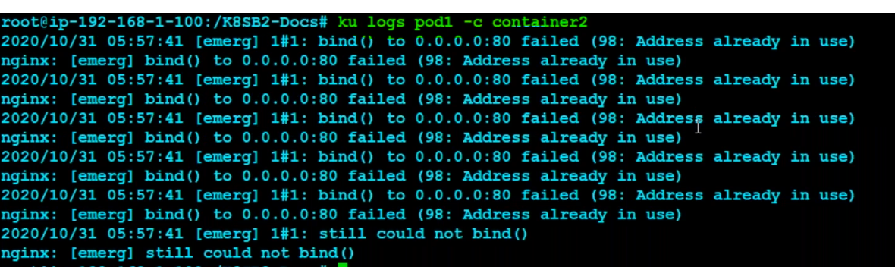

26 kubectl create vs kubectl apply

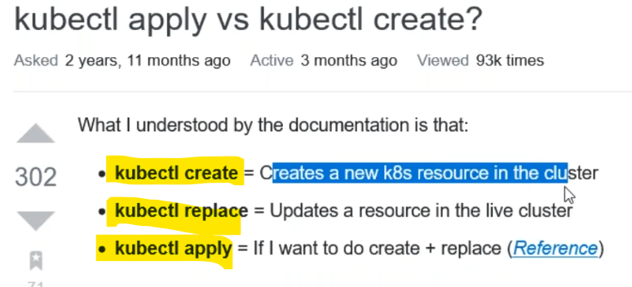

27.wt is advantage of side car container?

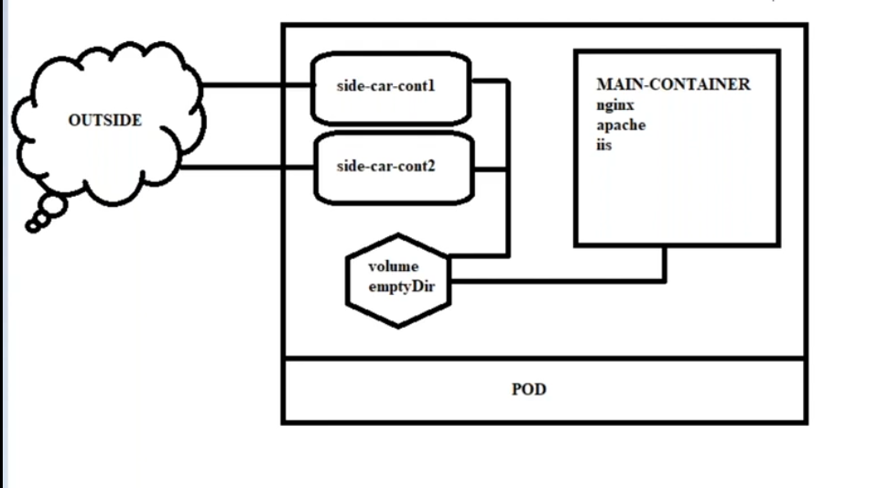

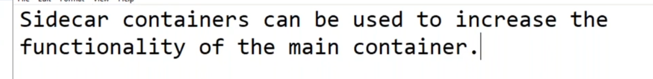

sidecar container used for copy logs from main container

without side car container main container use only web applicatio process but side car for log purpose

types

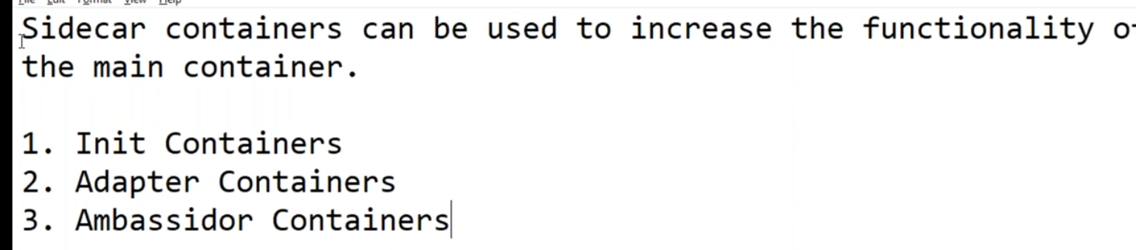

28.wt is init container?

take backup of file of container before start conatiner

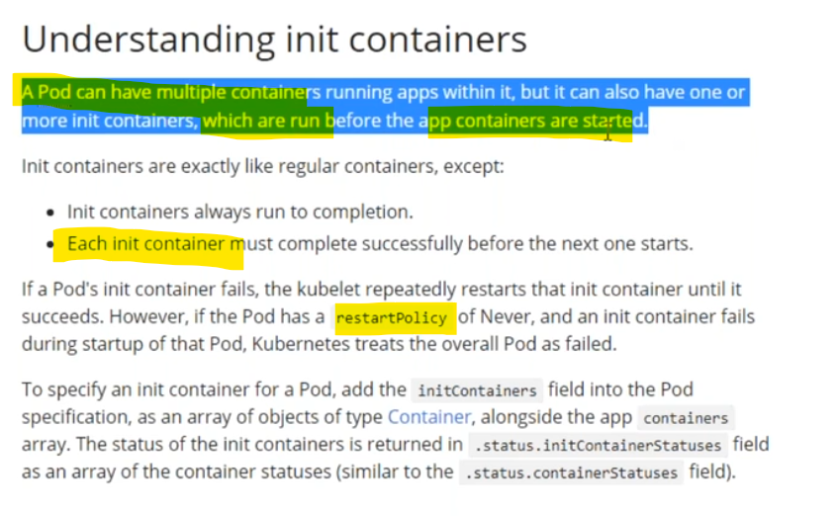

wt is adapter container?

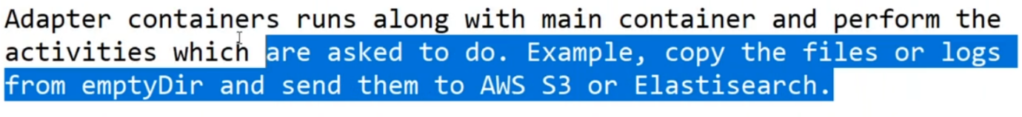

29.wt is readiness probe?

specific site it is reaching or not or specific path reached or not we can use

readiness use for staring

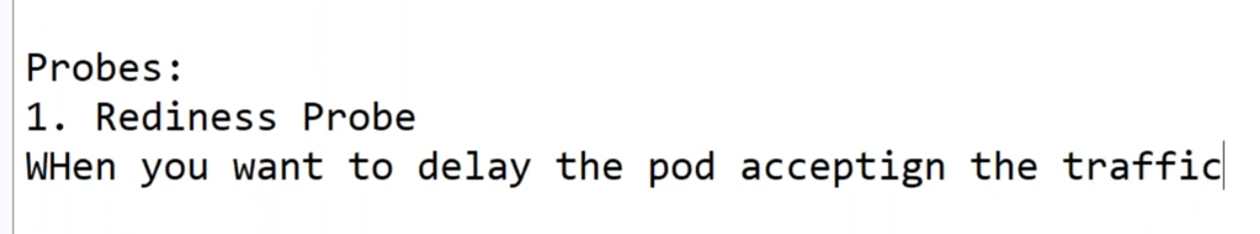

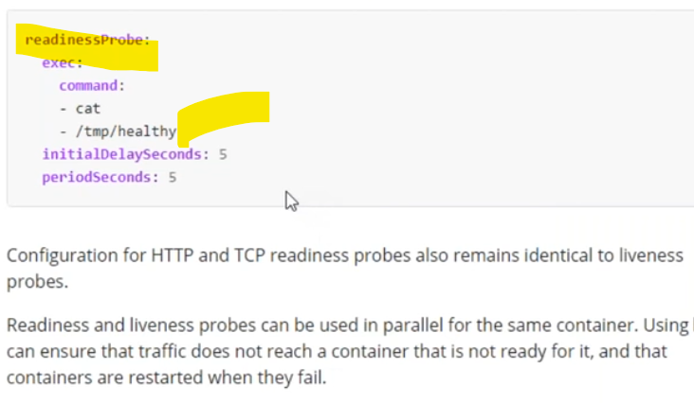

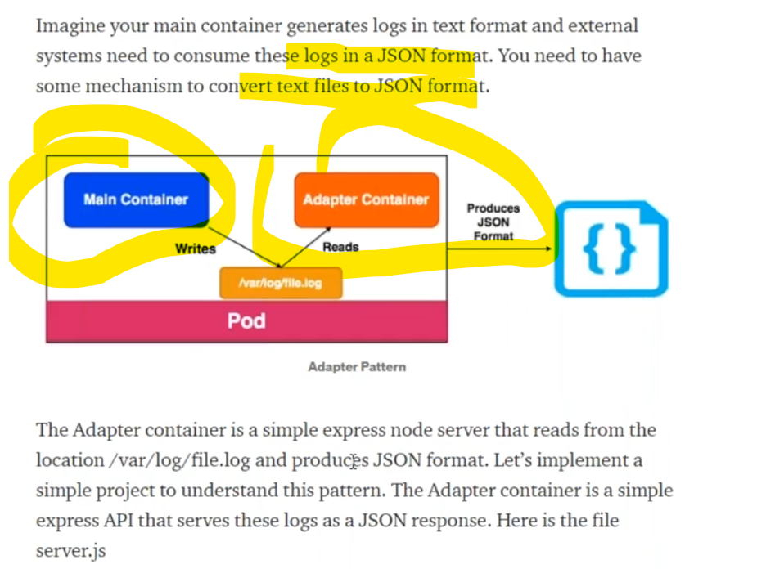

wt is use case of live ness probe?

live use after run main container

readiness probe before start main container

1,read the file

2,https request

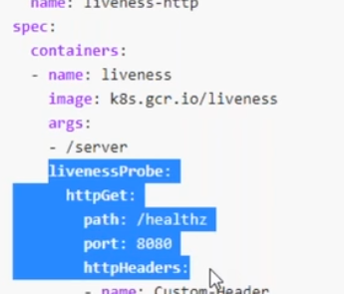

30.how to enter the pod?

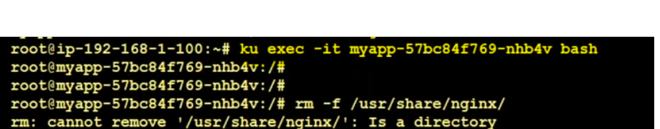

31.wt are volumes in k8s?

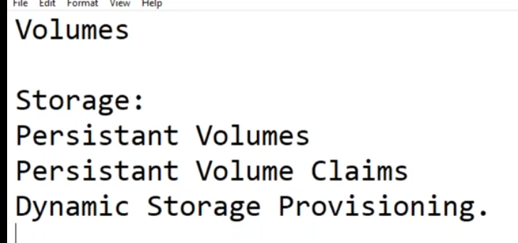

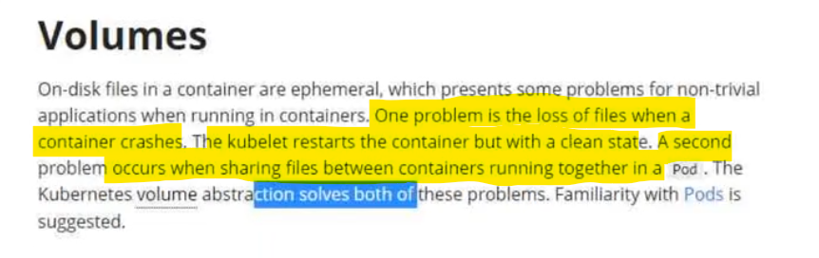

32.wt is emptydir in k8s?

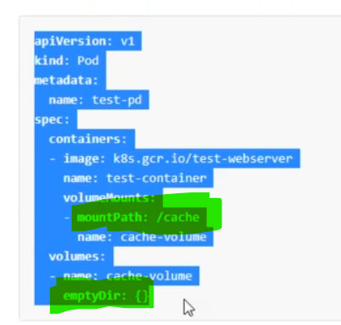

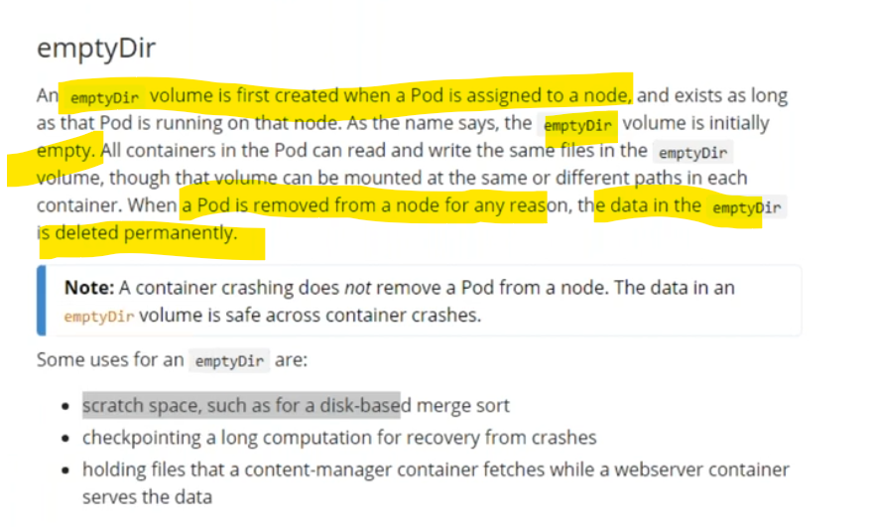

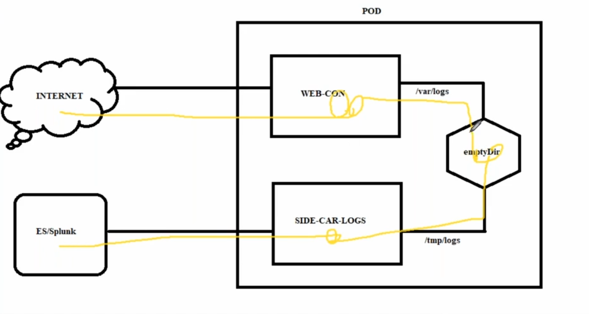

we can mount the different paths by using volumes

33,.wt are the volumes in k8s?

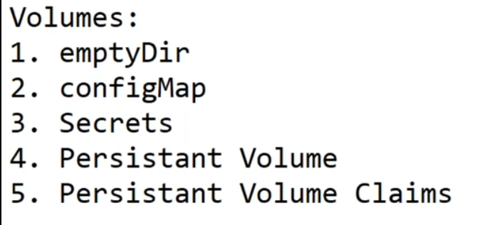

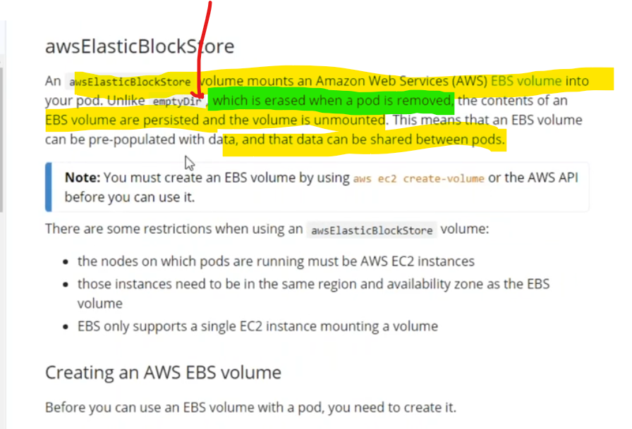

34.wt is config map in k8s?

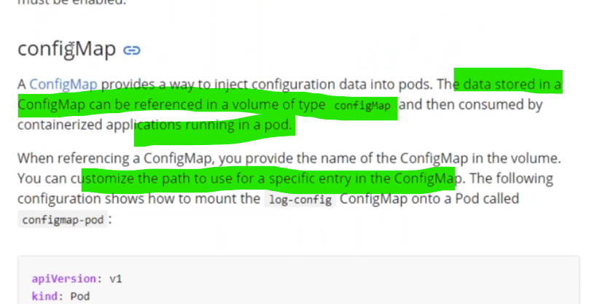

35.wt is use case of nfs in k8s?

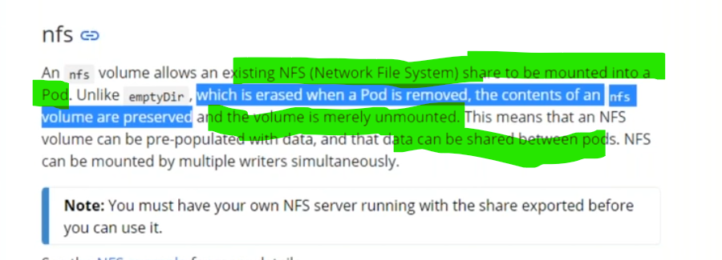

36.how to create namespace in k8s?

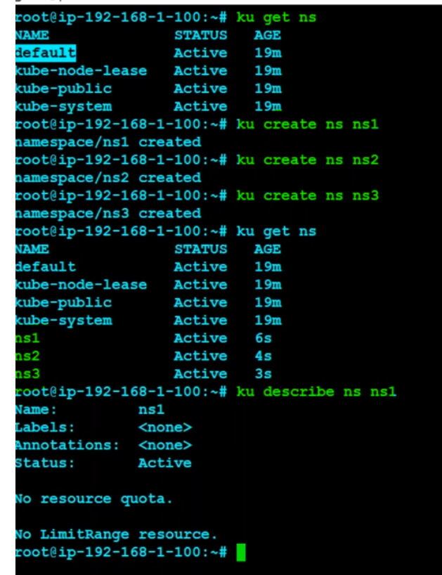

37.

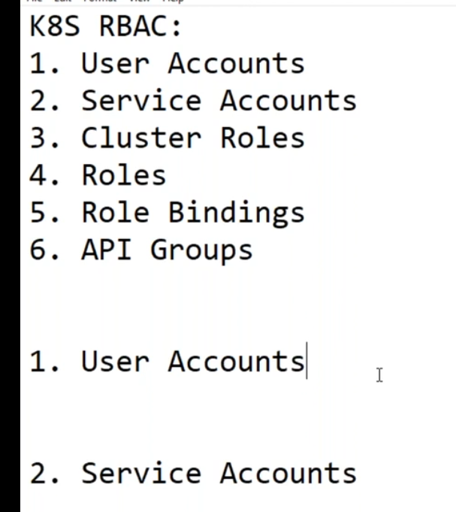

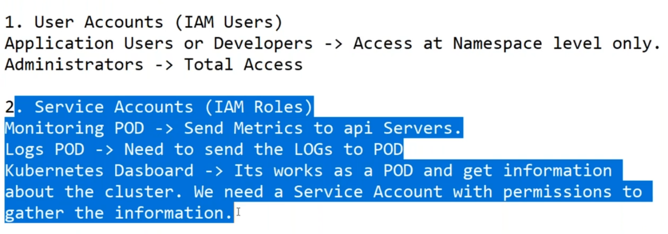

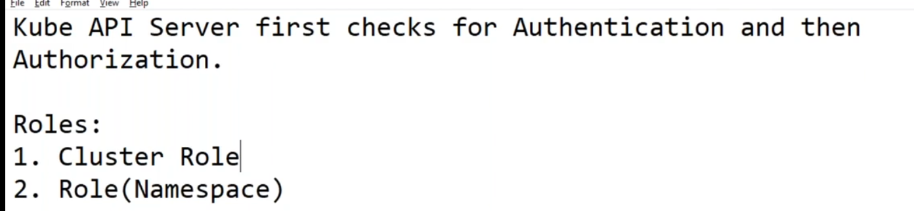

37.

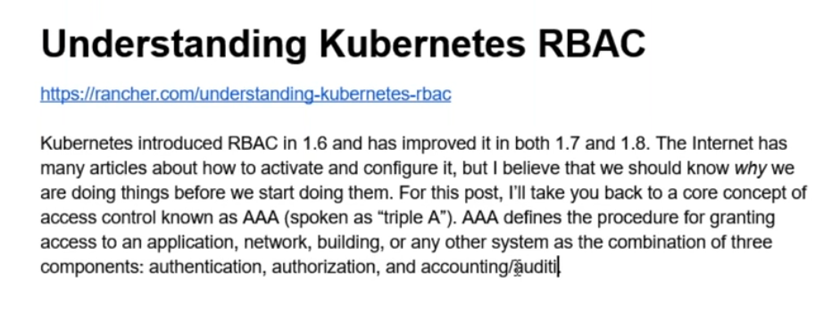

38.

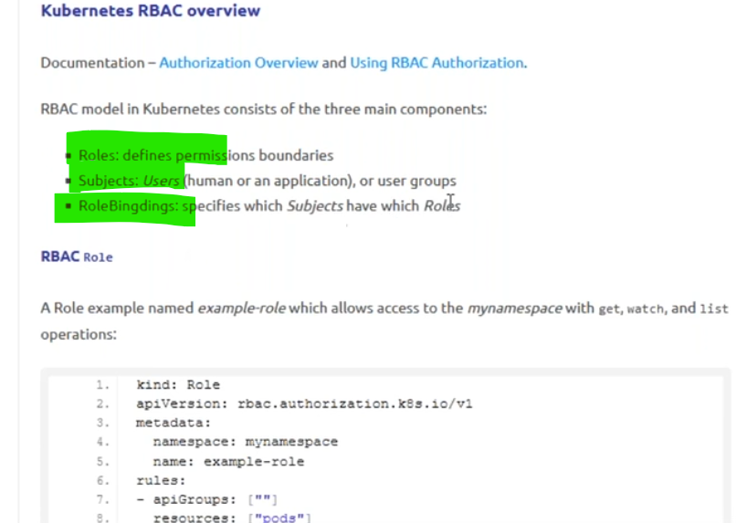

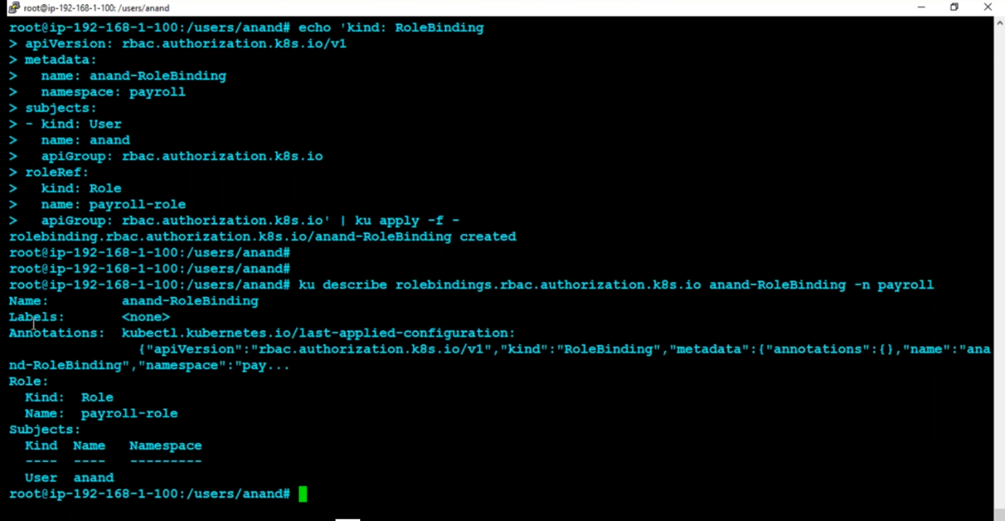

39. wt is diff between pv and pvc?

40.wt is emdir in k8s?

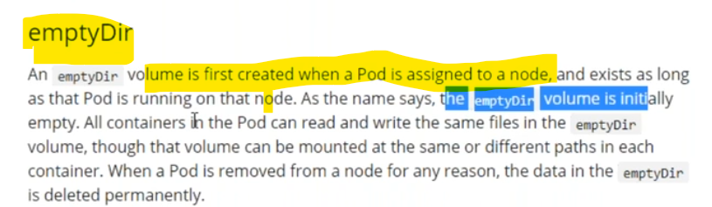

empty dir created when pod is assigned to a node

emdir is default volume

if pod is deleted and then default emdir vol also deleted

41. drawback of k8s volume?

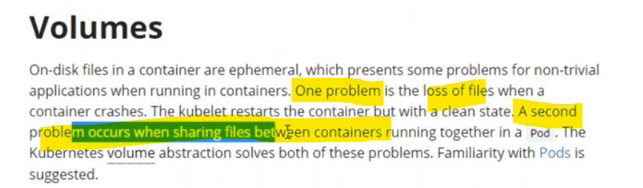

42. wt are types of volumes in k8s/

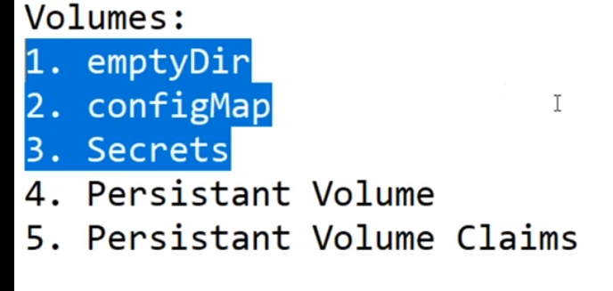

43. K8s secrets…?

we can store in certificates & SSL  certificates

44. How to create the secrets…?

ANS:- 

           After the Encode the Password it generates the Code like this



After generating the you have to decode it like this



45.How to access the secrets inside the POD…?

46. can u please write service port in manifest file?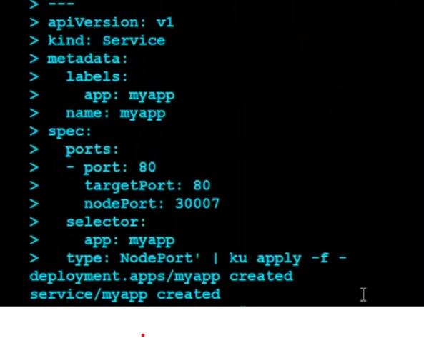apiversion: v1

kind : service

metadata:

  labels:

   app: nginx

   name: nginx

spec:

 port:

 - port: 80

  targetport:80

  nodeport: 3003

selector:

app: nginx

type: nodeport

48. how to create secret

secret is a name space dependencies

other way secret creation



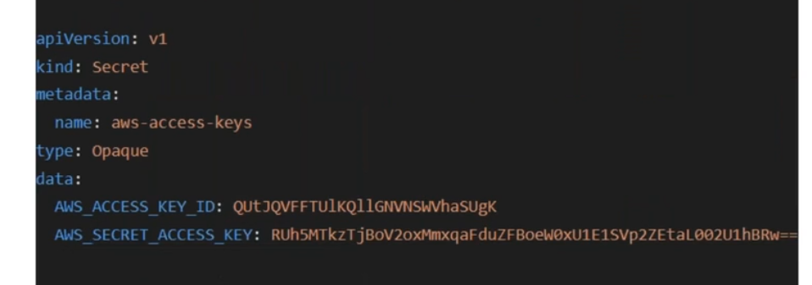

1.apiversion: v1

kind: secret

metadata:

  name: aws-access-keys

type:opaque

data:

 aws_access_key_id:

AWS_SECRET_ACCESS_KEY:

2.

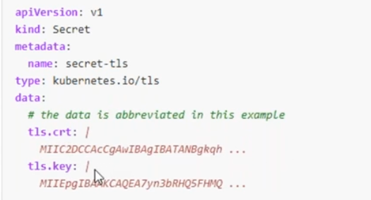

apiversion : v1

kind: secret

metadata:

 name: secret_tls

type: kubernetes.io/tls

data:

   tls.crt:

   tls.key:

49. how to get information of secret?

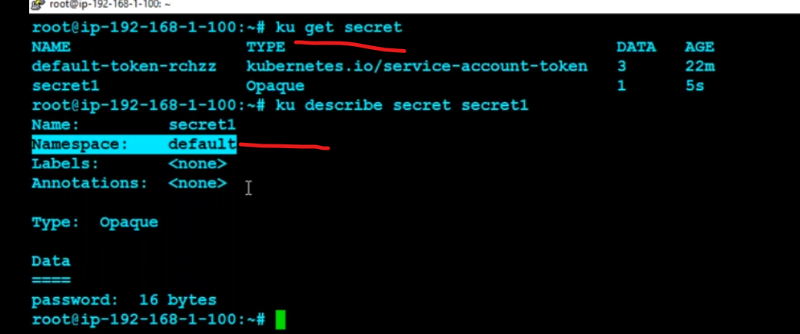

50.wt is draw back of ebs volumes?

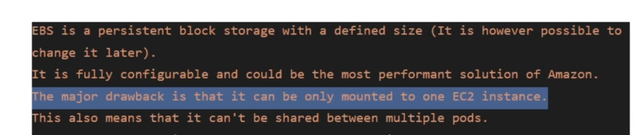

51.wt is raw disk in k8s & please write how to map ebs to pod?

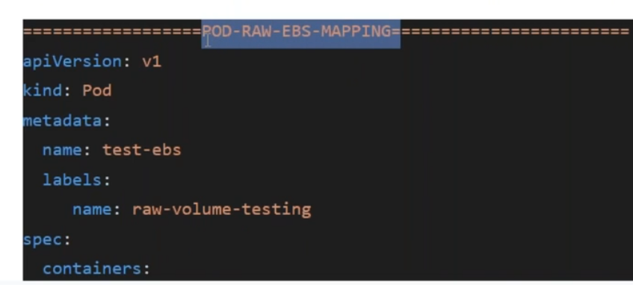

1.create pod deployemt and then

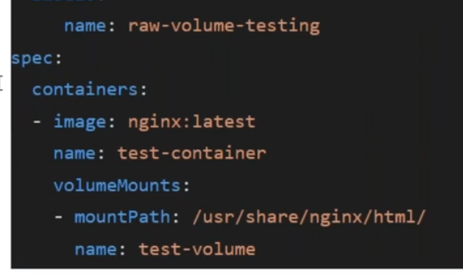

write voluemount path & volume name in  volume mount and then give volume id &type of volumes in elastic black storage

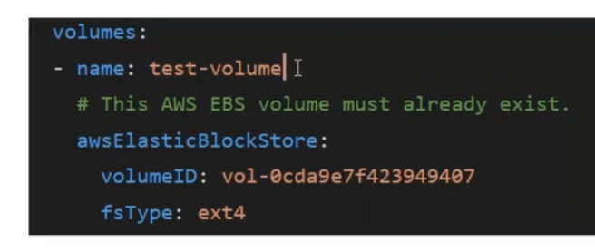

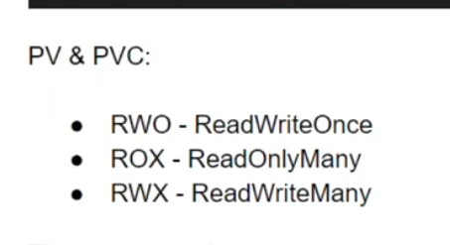

52.where using node selector in k8s?

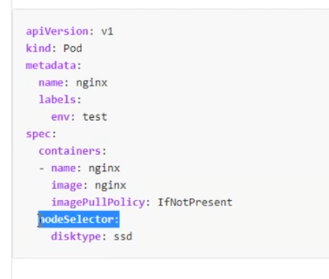

real pv attach to pod

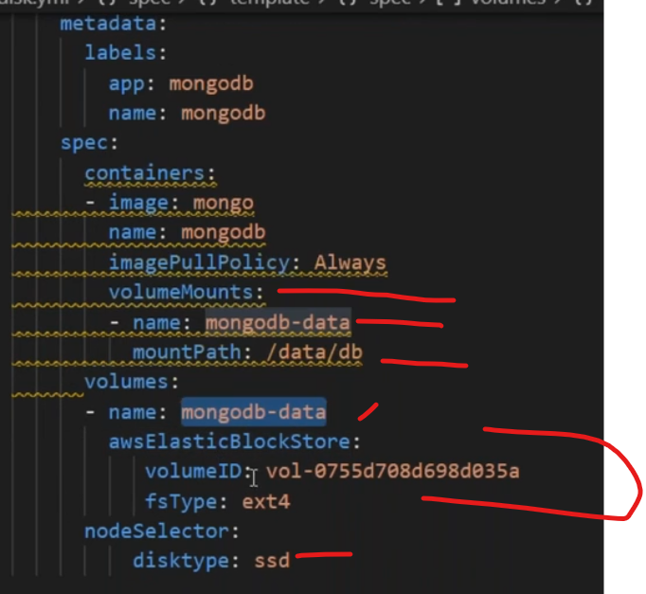

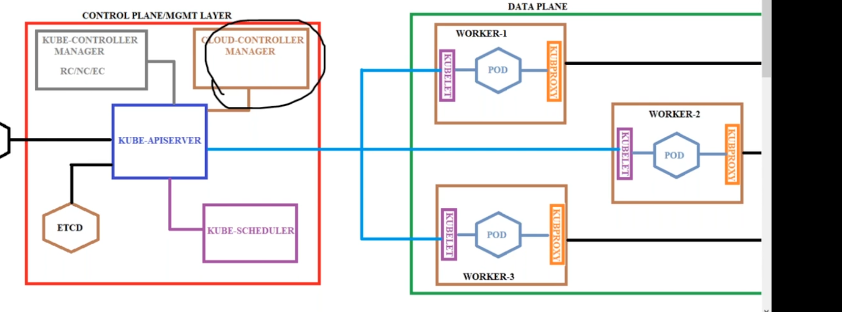

cloud controller manger help create lb & volumes attached to cluster env

how to check pods in specific name space?

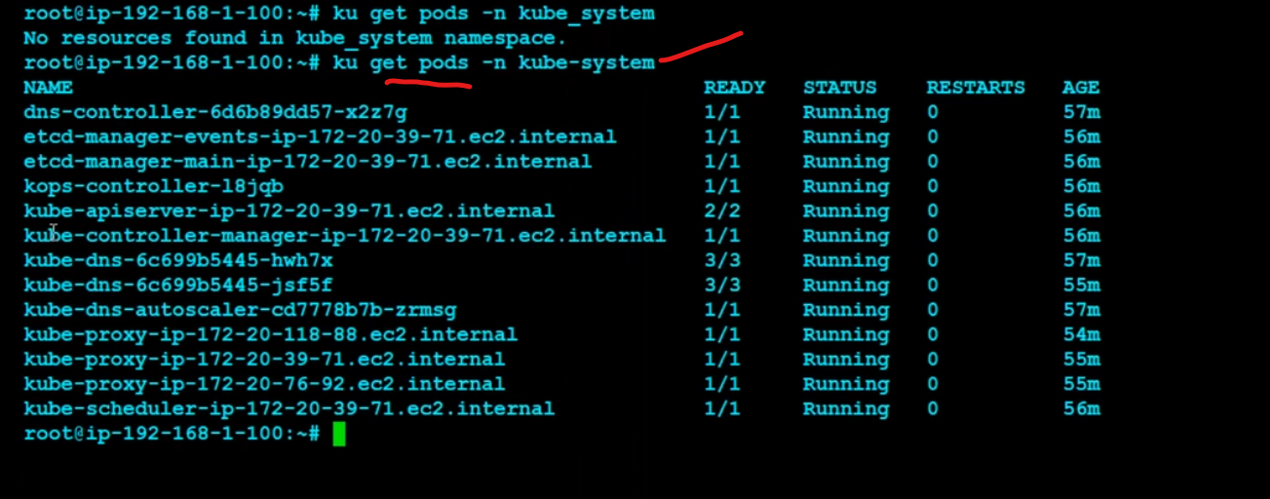

how to  check details information of pod?

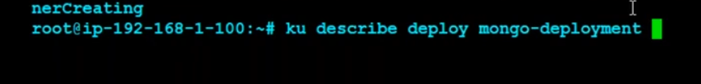

wt is diff between target port vs node port?

Target Port: Target port is the port on the POD where the service is running. Nodeport:

 Node port is the port on which the service can be accessed from external users using Kube-Proxy. The port is 8080 which represents that order-service can be accessed by other services in the cluster at port 8080.

wt is headless services in k8s?

Kubernetes offers a service component called headless services.

When using a headless service, Kubernetes doesn’t allocate a dedicated cluster IP address or perform load balancing. Instead, all the pods that are assigned to the service are connected to the service. The pods' IP addresses are recorded in DNS as the service's A records. An nslookup on the headless service returns all the pods' IP addresses with the corresponding selector.s

how to use ingress in k8s?

Kubernetes Ingress is an API object that provides routing rules to manage external users' access to the services in a Kubernetes cluster, typically via HTTPS/HTTP. With Ingress, you can easily set up rules for routing traffic without creating a bunch of Load Balancers or exposing each service on the node.s

Kubernetes Ingress is an API object that provides routing rules to manage external users' access to the services in a Kubernetes cluster, typically via HTTPS/HTTP. With Ingress, you can easily set up rules for routing traffic without creating a bunch of Load Balancers or exposing each service on the node.

write yaml file for config map in k8s?

kind: ConfigMap

apiVersion: v1

metadata:

  name: example-configmap

data:

  # Configuration values can be set as key-value properties

  database: mongodb

  database_uri: mongodb://localhost:27017

  # Or set as complete file contents (even JSON!)

  keys: |

    image.public.key=771

    rsa.public.key=42

The key to adding your ConfigMap as environment variables to your pods is the envFrom property in your Pod’s YAML.

<https://matthewpalmer.net/kubernetes-app-developer/articles/configmap-example-yaml.html#:~:text=Creating%20a%20ConfigMap,yaml%20.&text=%23%20Or%20set%20as%20complete%20file%20contents%20(even%20JSON!)>

how to create headless service in k8s?

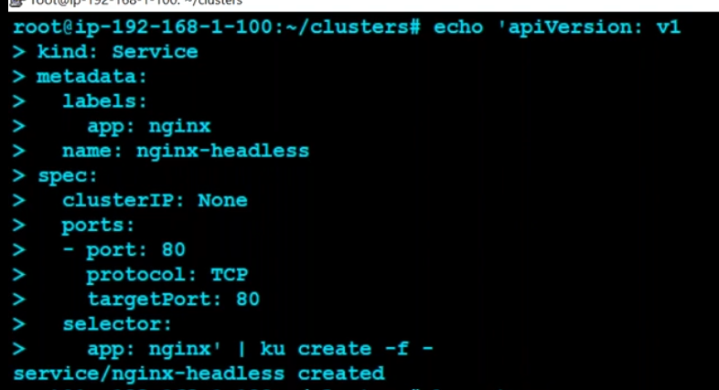

apiversion: v1

kind: service

metadata:

    labes:

     app/; nginx

   name: nginx-headless

spec:

   clusterip: none

   port:

-protocol ;tcp

targetport: 80

selector

 app: nginx |

wt is use case of headless service?

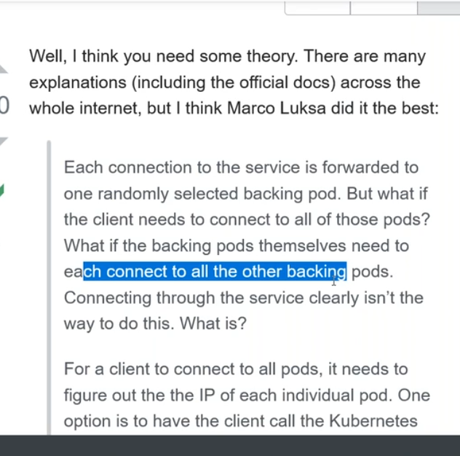

What are some legitimate use cases for it?

* Create Stateful service.
* Deploying RabbitMQ or [Kafka](https://portworx.com/kafka-kubernetes/) (or any message broker service) to Kubernetes requires a stateful set for RabbitMQ cluster nodes.
* Deployment of Relational databases

What exactly is a headless service.

It is used for discovering individual pods(especially IPs) which allows another service to interact directly with the Pods instead of a proxy. With [NodePort](https://kubernetes.io/docs/concepts/services-networking/service/#type-nodeport), [LoadBalancer](https://kubernetes.io/docs/concepts/services-networking/service/#loadbalancer), [ExternalName](https://kubernetes.io/docs/concepts/services-networking/service/#externalname), and ClusterIP clients usually connect to the pods through a Service ([Kubernetes Services simply visually explained](https://medium.com/swlh/kubernetes-services-simply-visually-explained-2d84e58d70e5)) rather than connecting directly.

Well, I think you need some theory. There are many explanations (including the official docs) across the whole internet, but I think Marco Luksa did it the best:

Each connection to the service is forwarded to one randomly selected backing pod. But what if the client needs to connect to all of those pods? What if the backing pods themselves need to each connect to all the other backing pods. Connecting through the service clearly isn’t the way to do this. What is?

   సేవకు ప్రతి కనెక్షన్ యాదృచ్ఛికంగా ఎంచుకున్న బ్యాకింగ్ పాడ్‌కు ఫార్వార్డ్ చేయబడుతుంది. అయితే క్లయింట్ ఆ పాడ్‌లన్నింటికీ కనెక్ట్ కావాలంటే? బ్యాకింగ్ పాడ్‌లు ప్రతి ఒక్కటి అన్ని ఇతర బ్యాకింగ్ పాడ్‌లకు కనెక్ట్ కావాలంటే ఏమి చేయాలి. సేవ ద్వారా కనెక్ట్ చేయడం స్పష్టంగా దీన్ని చేయడానికి మార్గం కాదు. ఏమిటి?

can u please write pv in mani fest file?

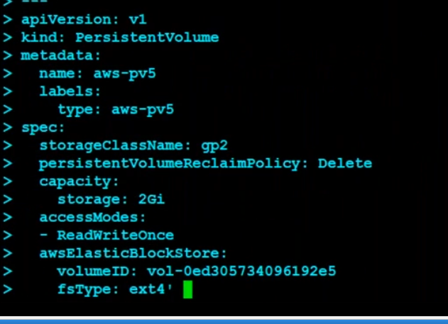

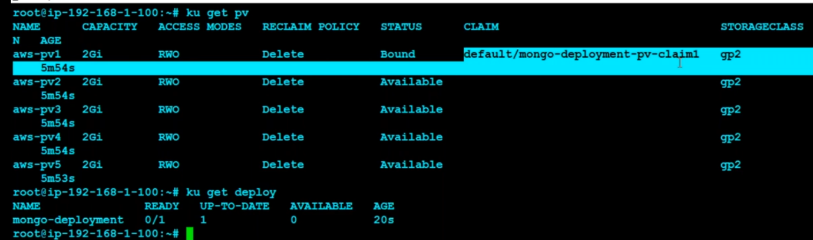

pvc

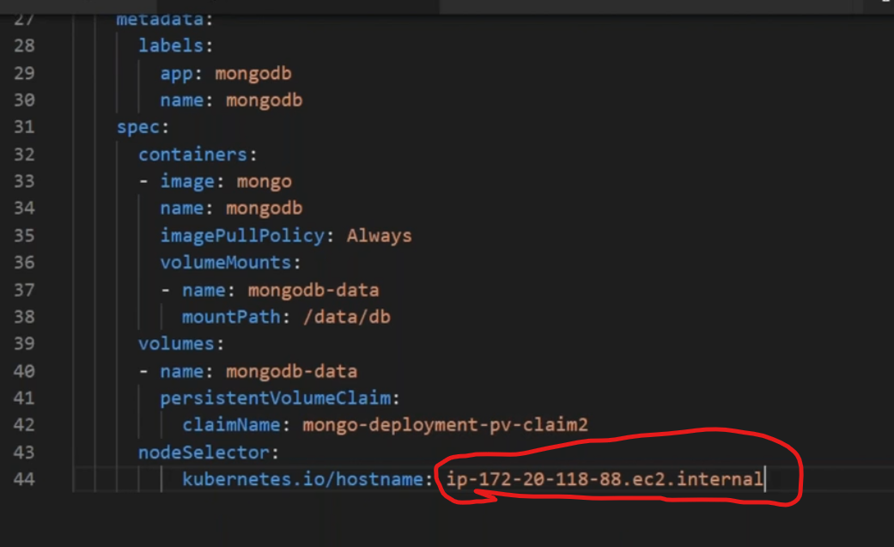

by using node selector volume attached node server

00.What is diff  b/w Statefullset & stateless set in K8S…?

ANS:- IF you’r using Statefullset when the POD goes down if any crashes issue happening in POD and resheduleing  it Stick the Name & Number Value there is No Changes in PODName & Value  and  A Statefullset is Always Stick to each of there Pod

But if using the StatelessSet in POD goes issue and goes wrong POD name will automatically Change in Every Resheduleing so this is the diff b/w Statefullset AND Stateless Set